

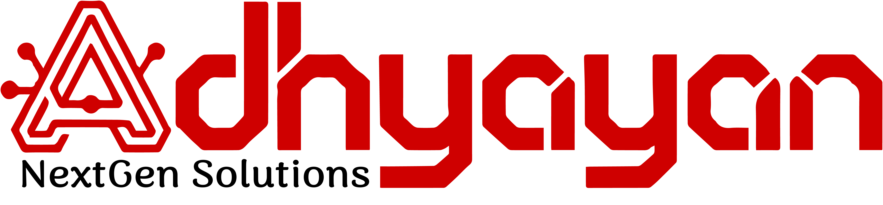

**Smart School**

**Management Platform**

**Adhyayan NextGen Solutions**

[**info@adhyayan.online**](mailto:info@adhyayan.online) **|** [**9522933330**](https://www.angspl.com/contact-us) **|** [**angspl.com**](http://www.angspl.com/)













**7. User Access Management**

* Secure control over user permissions.

**6. Referral | Affiliate Management**

* Grow your network and track affiliate contributions.

**5. Online Attendance (Employees)**

* Real-time tracking with GPS.

**4. Online Study Material**

* Centralized access to learning resources.

**3. Online Exams**

* Easy scheduling and remote examination.

**2. Online Fee Payment**

* Secure and convenient fee transactions.

**1. Seamless Online Admission**

* Streamlined digital student enrollment.